Delete Menu

By selecting “DELETE” from the “Main Menu”, a form to search for the reference material is presented to the user.

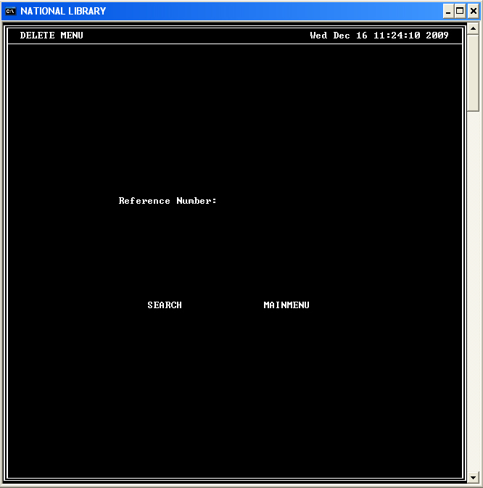

After entering a valid reference number:

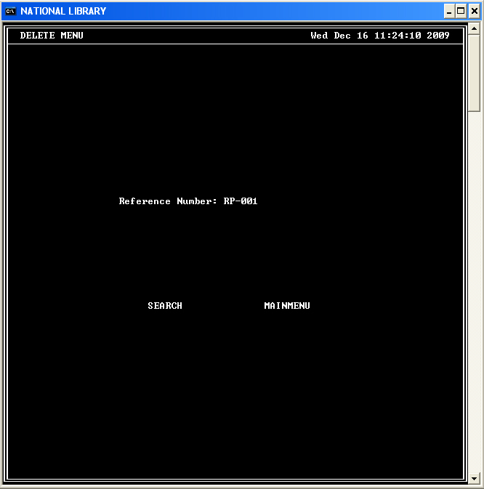

The user can search for the material or cancel the operation. If the user selects search, a search is done for the reference material with the reference number provided. If the record is found, the user will be presented with the menu shown below.

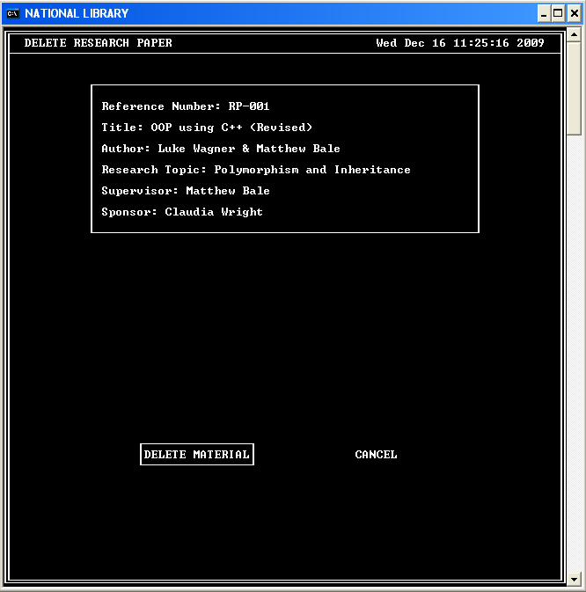

The user can then choose to delete the material or cancel the action. Upon selecting to delete, the following screen will be showed to the user.

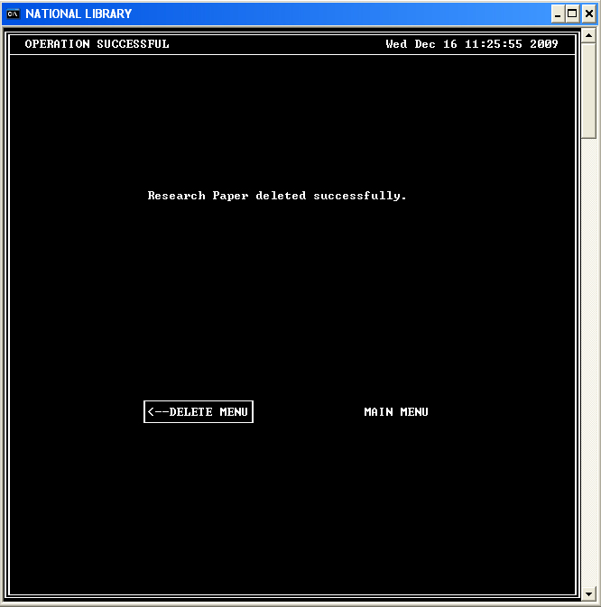

The user can return to the ”Delete Menu” or to the “Main Menu”.

